Task 4 – Journey of food
Taleah Ambler
Pasta

Mouth and oesophagus
After the plain pasta Is ingested, the food is in the oral cavity. It is immediately covered in saliva that enhances taste as saliva acts as a solvent for taste substances which then brings the taste down to the taste buds located in the tongue.

Usually the mouth then acts in “chewing”, a form of mechanical digestion which is assisted by the teeth and tongue (as well as saliva) breaking down the large complex piece of pasta into smaller pieces to increase the efficiency of chemical digestion in the mouth.

The pasta starts digestion, the amylase assist, located in your saliva which cover the now little pieces of pasta and start to breakdown the carbohydrates or starch in the pasta into simple sugars, though the rest of the molecules inside the pasta is digested later down the alimentary canal as the saliva only contains the enzyme to partly breakdown the carbohydrates – Amylase.

The tongue turns the food pieces into a singular piece sticking it together with the saliva adhering it together, making a “bolus” helpful for swallowing, pushing it down to the oesophagus.

With the help of peristalsis – an involuntary nerve impulsion – the food bolus slides down the oesophagus to the stomach, where the digestion continues, and protein digestion starts.
Some fats are absorbed in the mouth and oesophagus, as for other molecules they are far to complex and need further digestion to be absorbed and used for bodily functions.
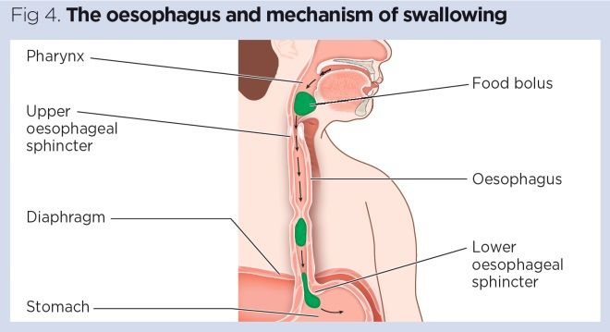
https://www.nursingtimes.net/clinical-archive/gastroenterology/gastrointestinal-tract-1-the-mouth-and-oesophagus-28-05-2019/

Stomach
After peristalsis occurs, the human body experiences “churning”, which are the motions occurring in one’s stomach as a part of the digestive tract, the pasta is broken down further through the movements of the muscular wall – of the stomach - that combines the pasta with stomach ”gastric” acid, this forms “chyme”, result of mechanical digestion.

At this point the pasta has gone from being a bolus to becoming chyme.
Amylase stop digesting the pasta when it reaches the stomach, because the acid in the stomach “gastric” acid prevents the enzyme(amylase) from working, so the partly digested carbohydrates stop digesting when the bolus hits the stomach, though digestion continues further along the alimentary canal.

Protease is found in the stomach (and small intestines), the enzyme starts to break up the protein found in the pasta into simple chains of amino acids and then further into individual molecules of amino acids.

Peristalsis (nerve impulses) moves the half-digested chyme(pasta) through the sphincter to the duodenum – the first part of the small intestine.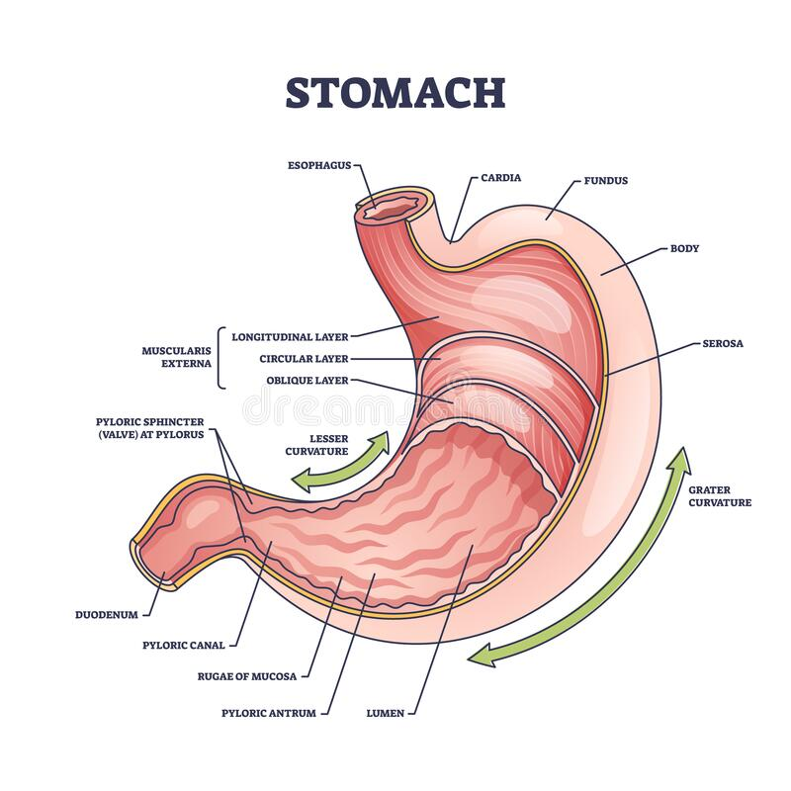
https://www.dreamstime.com/stomach-anatomy-digestive-organ-detailed-inner-structure-outline-diagram-stomach-anatomy-digestive-organ-detailed-inner-image254218752

Small intestines(breakdown)
The chyme is pushes through the sphincter to the duodenum where processes called segmentation and emulsification breakdown the food further.

Segmentation = alimentary canal contracts both behind and in front of the food, creating segments or sections in the canal, helping food to mix with digestive juices, maximising absorption.

Emulsification = Take larger fat molecules are converted to smaller fat globules, bile enters small intestines (liver), fat globules mix with bile breakdown into emulsion droplets, it increases the surface area of the fat on which the enzyme (lipase) can act upon.

Powerful enzymes are secreted to the small intestines received from liver, gallbladder(bile) and pancreases including Protease, Amylase and Lipase are all found in the small intestines finish the breakdown of proteins (Protease), carbohydrates (Amylase), and fatty acid + glycerol (Lipase).

Segmentation slows further down in the small intestines, though peristalsis pushes the Ileocecal valve to enter the large intestines after processes of finishing the absorption of the pasta’s nutrition.

Small intestines(absorption)
Thanks to the inner layer of the alimentary canal mucosa, especially in the small intestines there are villi and microvilli, it increases the surface area to absorb any nutrience that molecules are simple enough to pass through the membrane of the small intestines.

Duodenum
- First part of small intestine, curving around pancreas before connecting to the rest of coiled intestines.
- Help break down food, ducts feed into duodenum to release powerful enzymes when food it present.

Jejunum
- Lower abdominal cavity, filled with many blood vessels.
- Mechanical digestions take place, churning food, segmentation, and peristalsis help to absorb and move the food along the canal.

Ileum
- Walls are thin and narrow, blood supply is reduced, water and nutrience are absorbed.
- Peristalsis takes over, waste moves towards the ileocecal valve to the large intestines letting the chyme pass through but preventing bacteria out by closing.

Carbohydrates – simple sugars
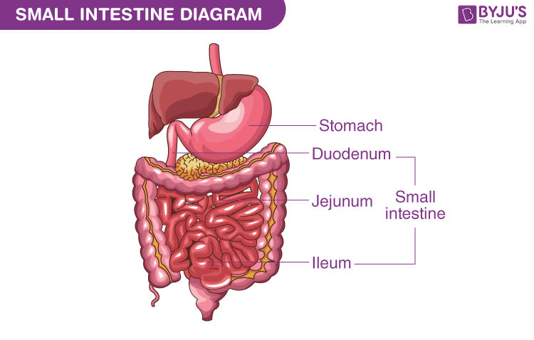
- The simple sugars in glucose are easily absorbed through the walls of the small intestines, requires active transport to enter the bloodstream.
  - Insulin made in the pancreases allows the broken-down carbohydrates to glucose molecules to be stored in an insoluble form, and to be stored as glycogen in the liver, its stored for anerobic respiration.
https://byjus.com/biology/small-intestine-diagram/

Proteins
- The proteins in the chyme are now broken down into amino acids and is released into your bloodstream in individual molecules of amino acids.
  - The body is unable to store proteins, its either used up or stored as fat.
Lipids
- Lipids after absorption in the small intestines get packages into chylomicrons and travel from the small intestines through and to the bloodstream in lymph vessels.
  - Lipids are stored in the liver or spleen.

Material breakdown and use
Carbohydrates
- Due to the simple sugars soluble structure, there is easy transferring across the small intestine membrane, active transport allows simple sugars to enter the bloodstream, then transferred to the liver where it is further disputed, providing the body with energy in the form of glucose to convert to energy by respiration in the body.
Proteins
- Protease in stomach break complex protein molecules into smaller chains of amino acids, which break into individual amino acids, proteins are absorbed in small intestines.
- Microvilli allow for larger / increased surface area for increasing the maximum amount of absorption, active transport help the amino acids to enter the bloodstream to build muscle and replenish tissue.
Lipids
- Some lipids get broken down and absorbed in the mouth and stomach, though most of the digestion comes from the small intestines and larger and more complex molecules need to be digested and broken down into simpler molecules then to be absorbed in the small intestines as they’re a component of cell membranes and they function as “storehouses”.

Large intestines
After the remains of the chyme (pasta) enters though the Ileocecal valve to the large intestines, mechanical digestion in the large intestines kick in as peristalsis breaks down any extra nutrience like proteins or starches located in the chyme that were not fully absorbed and digested in the small intestines, pushing the chyme (remains of the pasta) through the rest of the large intestines.

There are no digestive enzymes produces or secreted, chemical digestion stops when the remains of the pasta enter the large intestines, due to breaking down of molecules are completed in the small intestines.

The large intestines absorb water and electrolytes, playing part in elimination and faeces, this is the part where the chyme become faeces.

Elimination and faeces
At this point all the water has absorbed food left undigested, bacteria, mucus and dead cells contracted along the alimentary canal, there is no food digested or absorbed.

Inventory contractions move the chyme along the large intestines.

Voluntary contraction of rectal muscle and relaxation of the internal anal sphincter, contractions of skeletal muscles of external anal sphincter give the release of the faeces.

The cecum descending colon
- Beginning of the colon
- Small intestine feeds – the remains of the pasta – into the cecum through the Ileocecal valve, widest part of large intestine, where food from the small intestine arrives in the large intestine.
- When the cecum descending colon is full involuntary muscle movements of the colon begins

Ascending colon
- Absorbs remaining water and other nutritious molecules, to solidify the faecal matter.

Descending colon
- Stores faeces that will be emptied into the rectum.

The sigmoid colon
- Contracts to increase the pressure inside of the colon causing the faeces to move into the rectum.

The rectum
- Holds the faeces waiting for the voluntary contractions of elimination and defecation.

The anus
- Facilitate bowel movements, creating the ability to hold and go to the toilet with surrounding nerves and muscles.
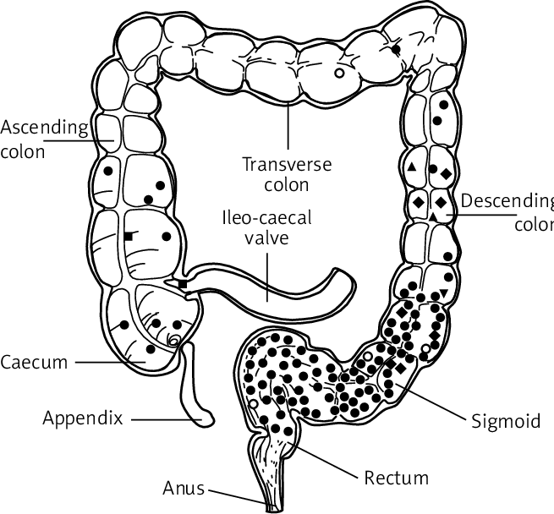
https://www.researchgate.net/figure/Location-map-of-the-colon-disease_fig1_282776079

References
34.10: Digestive System Processes - Digestion and Absorption. (2018, July 16). Biology LibreTexts. https://bio.libretexts.org/Bookshelves/Introductory_and_General_Biology/Book%3A_General_Biology_(Boundless)/34%3A_Animal_Nutrition_and_the_Digestive_System/34.10%3A_Digestive_System_Processes_-_Digestion_and_Absorption
Becky, Ashley, Nikki, & Sophie. (2012, May 6). The Digestion Process of Pasta. Prezi.com. https://prezi.com/jrkah7ctry7h/the-digestion-process-of-pasta/#:~:text=After%20some%20of%20the%20carbohydrates
Bolus (digestion). (2023, March 13). Wikipedia. https://en.wikipedia.org/wiki/Bolus_(digestion)#:~:text=In%20digestion%2C%20a%20bolus%20(from
Carr, L. (2009). Lipid Storage - an overview | ScienceDirect Topics. Www.sciencedirect.com. https://www.sciencedirect.com/topics/medicine-and-dentistry/lipid-storage#:~:text=Lipid%20storage%20(especially%20sphingolipid%20and
Kamiya, A. (2023, September 2). Small Intestine Absorption (Villi and Microvilli) and Digestion. Study.com. https://study.com/academy/lesson/small-intestine-nutrient-absorption-and-role-in-digestions.html#:~:text=Absorption%20in%20the%20small%20intestine%20occurs%20in%20the%20villi%20and
Mechanical Digestion | BioNinja. (n.d.). Ib.bioninja.com.au. Retrieved May 7, 2023, from https://ib.bioninja.com.au/standard-level/topic-6-human-physiology/61-digestion-and-absorption/mechanical-digestion.html#:~:text=Segmentation%20involves%20the%20contraction%20and
Peyrot des Gachons, C., & Breslin, P. A. S. (2016). Salivary amylase: Digestion and metabolic syndrome. Current Diabetes Reports, 16(10). https://www.ncbi.nlm.nih.gov/pmc/articles/PMC6825871/
Roland, J. (2019, January 16). Why Are Enzymes Important? Healthline. https://www.healthline.com/health/why-are-enzymes-important

